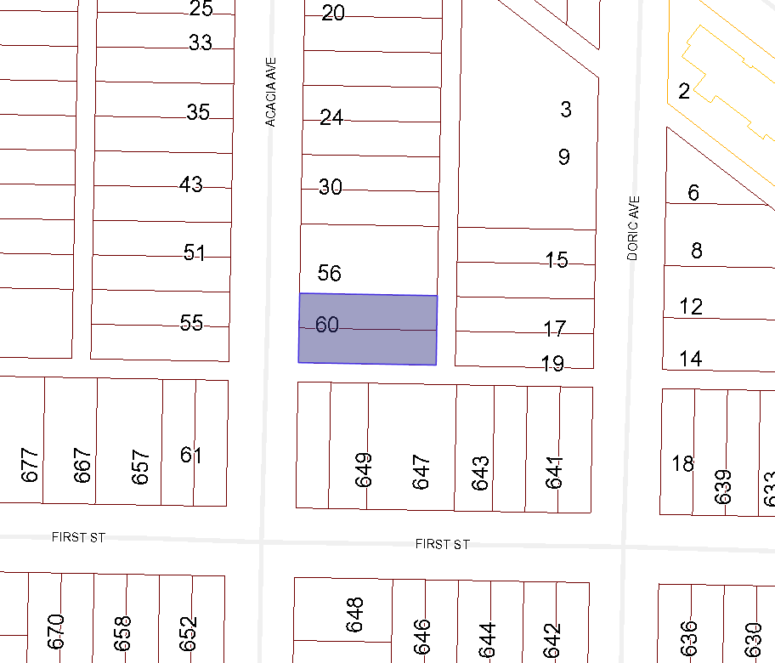
BOARD OF VARIANCE APPLICATION BOV00674

LOCATION MAP

CIVIC: 60 ACACIA AVENUE

LEGAL: LOT 39 AND 40, BLOCK 7, SECTION 1, NANAIMO DISTRICT, PLAN 1465

